**Docker task**

1. **Installing docker**

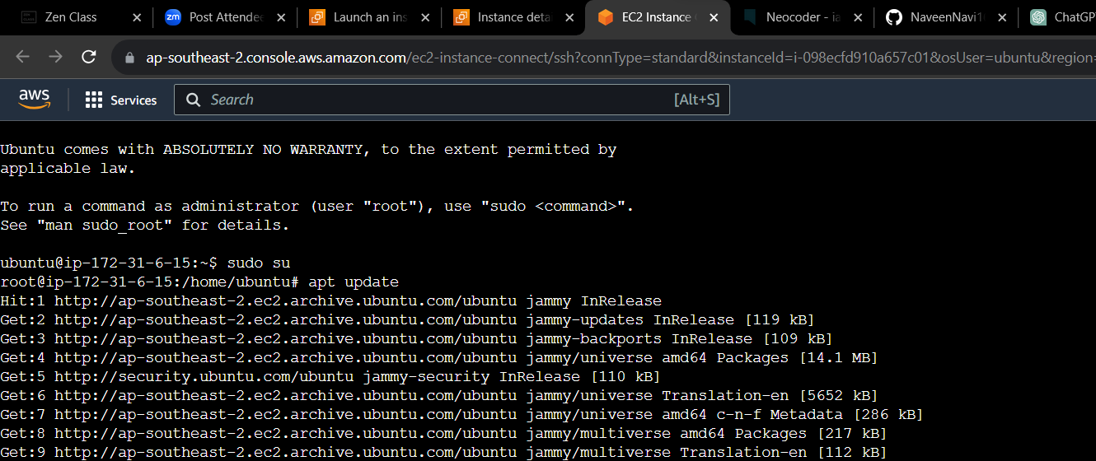

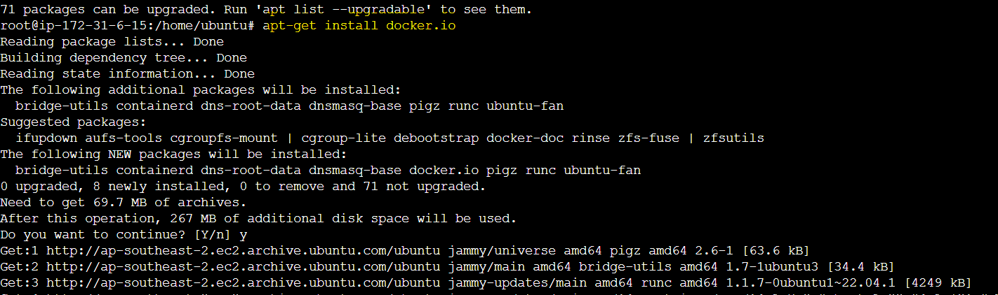2. **Cloning git repo**  
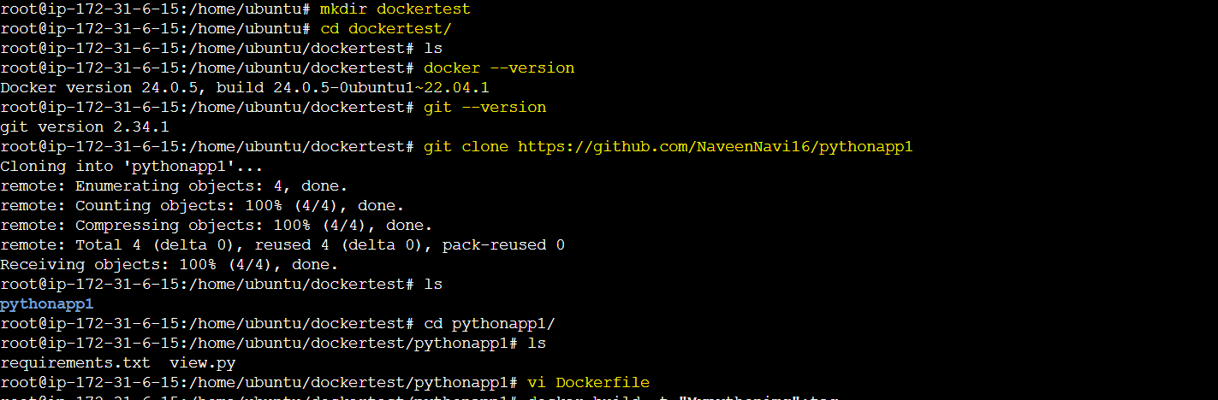3.**Dockerfile**

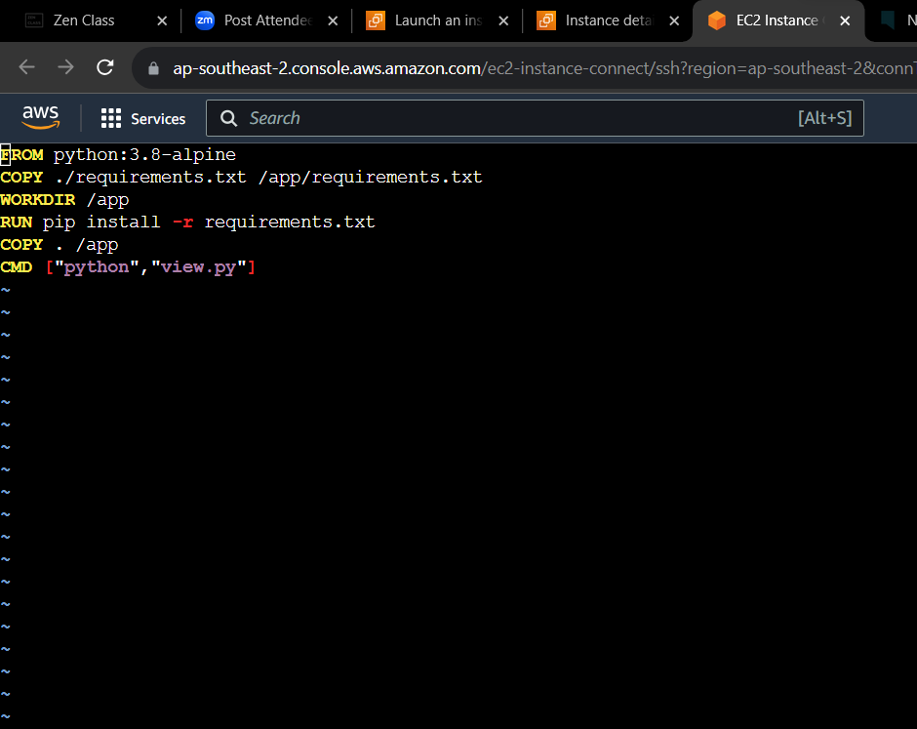

4.**Building base image**

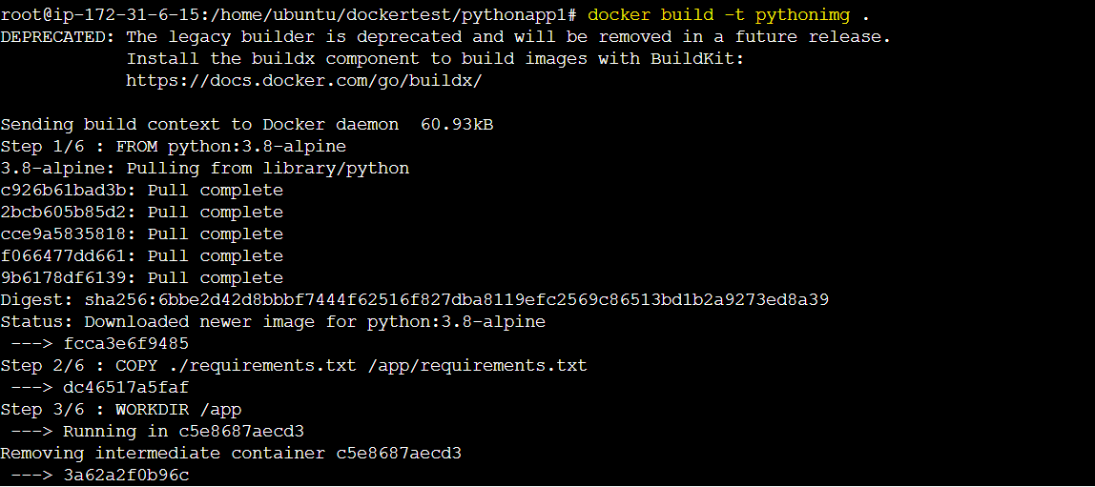

5.**creating containers**